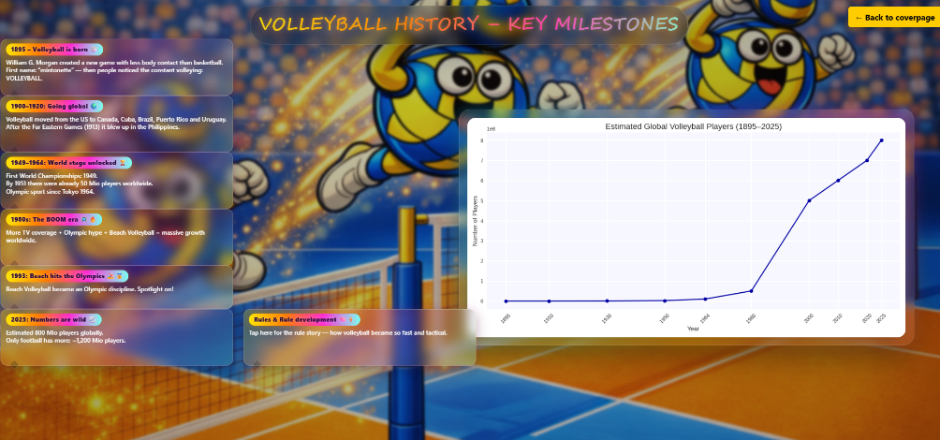

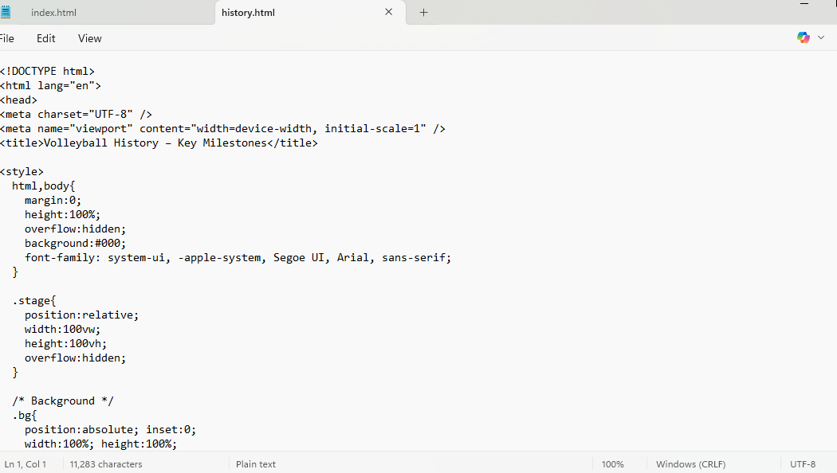

Page “history.html”
Code for page “history.html”, notepad

<!DOCTYPE html>
<html lang="en">
<head>
<meta charset="UTF-8" />
<meta name="viewport" content="width=device-width, initial-scale=1" />
<title>Volleyball History – Key Milestones</title>

<style>
html,body{
margin:0;
height:100%;
overflow:hidden;
background:#000;
font-family: system-ui, -apple-system, Segoe UI, Arial, sans-serif;
}

.stage{
position:relative;
width:100vw;
height:100vh;
overflow:hidden;
}

/* Background */
.bg{
position:absolute; inset:0;
width:100%; height:100%;
object-fit:cover;
transform:scale(1.02);
transition:filter 1.2s ease, opacity 1.2s ease;
user-select:none; pointer-events:none;
opacity:1;
z-index:1;
}

.veil{
position:absolute; inset:0;
background:radial-gradient(circle at 50% 35%, rgba(0,0,0,.00), rgba(0,0,0,.18));
opacity:0;
transition:opacity 1.2s ease;
pointer-events:none;
z-index:2;
}

/* Title */
.titleWrap{
position:fixed;
top:18px;
left:50%;
transform:translateX(-50%);
z-index:2147483000;
width:min(1100px, 94vw);
display:flex;
justify-content:center;
pointer-events:none;
}

.title{
margin:0;
padding:10px 18px;
border-radius:999px;
background:rgba(0,0,0,.22);
border:1px solid rgba(255,255,255,.14);
backdrop-filter: blur(10px);
box-shadow:0 18px 46px rgba(0,0,0,.25);
font-family: "Segoe Script","Comic Sans MS","Brush Script MT","Trebuchet MS",system-ui,sans-serif;
font-weight: 700;
letter-spacing: .6px;
text-transform: uppercase;
font-size:clamp(18px, 2.5vw, 34px);
}

.title span{
background: linear-gradient(90deg, #ffe600 0%, #ff7a00 35%, #ff2bd6 70%, #7cffef 100%);
-webkit-background-clip:text;
background-clip:text;
color:transparent;
text-shadow:
0 0 10px rgba(255,230,0,.35),
0 0 18px rgba(255,50,214,.25),
0 10px 30px rgba(0,0,0,.35);
}

.caret{
display:inline-block;
width:10px;
margin-left:6px;
border-right:3px solid rgba(255,230,0,.85);
transform: translateY(2px);
animation: blink 800ms steps(1) infinite;
}
@keyframes blink{ 50%{opacity:0;} }

/* Content (chart pushed to right) */
.content{
position:absolute;
inset:0;
display:flex;
align-items:center;
justify-content:flex-end;
padding-right:4vw;
padding-left:22vw;
z-index:10;
}

.card{
width:min(900px, 62vw);
opacity:0;
transform: translateY(18px) scale(.97);
transition: opacity 900ms ease, transform 900ms cubic-bezier(.2,.9,.2,1);
position:relative;
}

.card-inner{
border-radius: 22px;
background: linear-gradient(180deg, rgba(255,255,255,.10), rgba(255,255,255,.04));
backdrop-filter: blur(8px);
box-shadow: 0 22px 60px rgba(0,0,0,.35);
border: 1px solid rgba(255,255,255,.14);
position:relative;
overflow:visible;
}

.card-inner::before{
content:"";
position:absolute; inset:-2px;
border-radius: 24px;
background: conic-gradient(from 180deg,
rgba(255,210,0,.90),
rgba(0,190,255,.85),
rgba(255,60,210,.75),
rgba(255,210,0,.90)
);
filter: blur(14px);
opacity:.38;
z-index:0;
}

.chart-wrap{ position:relative; z-index:1; padding:16px; }

.chart-img{
width:100%;
height:auto;
display:block;
border-radius:16px;
box-shadow:0 18px 42px rgba(0,0,0,.28);
filter:saturate(1.15) contrast(1.08) brightness(1.02);
background: rgba(255,255,255,.92);
}

/* Bubble layer */
#bubbleLayer{
position:fixed;
inset:0;
z-index:2147483647;
pointer-events:none;
}

/* same frame size */
.bubble{
position:fixed;
width: 460px;
height: 112px;
padding: 8px 10px;
border-radius: 14px;
box-sizing: border-box;

background: linear-gradient(135deg,
rgba(255,230,0,.25),
rgba(255,45,214,.20),
rgba(124,255,239,.18)
);
border: 1px solid rgba(255,255,255,.25);
color: rgba(255,255,255,.98);

font-family: "Segoe UI", system-ui, Arial, sans-serif;
font-weight: 600;
font-size: 12px;
line-height: 1.3;

box-shadow:
0 10px 22px rgba(0,0,0,.25),
0 0 18px rgba(255,45,214,.14);

backdrop-filter: blur(10px);

opacity:0;
transform: translateY(8px) scale(.97);
transition: opacity 520ms ease, transform 520ms cubic-bezier(.2,.9,.2,1);
}
.bubble.show{ opacity:1; transform: translateY(0) scale(1); }

/* 1993 smaller */
.bubble.short{ height: 86px; }

.bubble::after{
content:"";
position:absolute;
width:12px; height:12px;
background: rgba(20,20,20,.22);
border-right: 1px solid rgba(255,255,255,.18);
border-bottom: 1px solid rgba(255,255,255,.18);
transform: rotate(45deg);
bottom:-6px;
left: 20px;
border-radius: 2px;
}

.badge{
display:inline-block;
padding:4px 10px;
border-radius:999px;
background:linear-gradient(90deg,#ffe600,#ff7a00,#ff2bd6,#7cffef);
color:#2a0b3f;
text-shadow:0 0 6px rgba(255,255,255,.35);
font-weight:900;
font-size:12px;
letter-spacing:.35px;
box-shadow:0 0 14px rgba(255,122,0,.45);
margin-bottom:6px;
}

.bubbleBody{
max-height: 64px;
overflow:hidden; /* no scrollbars */
white-space:pre-wrap;
}
.bubble.short .bubbleBody{ max-height: 40px; }

/* Reveal */
.stage.reveal .bg{ filter: blur(2px) saturate(.95) contrast(.98); opacity:.78; }
.stage.reveal .veil{ opacity:1; }
.stage.reveal .card{ opacity:1; transform: translateY(0) scale(1); }

/* Back button */
.backBtn{
position:fixed;
right:20px;
top:20px;
z-index:10000;
padding:10px 15px;
background:#ffcc00;
color:#000;
font-weight:bold;
text-decoration:none;
border-radius:5px;
box-shadow: 0 2px 8px rgba(0,0,0,0.2);
}
</style>
</head>

<body>
<div class="stage" id="stage">
<img class="bg" src="history-bg.png" alt="bg">
<div class="veil"></div>

<div class="titleWrap">
<div class="title">
<span id="titleText"></span><span class="caret" id="caret"></span>
</div>
</div>

<div class="content">
<div class="card" id="card">
<div class="card-inner">
<div class="chart-wrap" id="chartWrap">
<img class="chart-img" id="chartImg" src="history-chart.png" alt="chart">
</div>
</div>
</div>
</div>
</div>

<div id="bubbleLayer"></div>
<a class="backBtn" href="index.html">← Back to coverpage</a>

<script>
const stage = document.getElementById("stage");
const titleText = document.getElementById("titleText");
const caret = document.getElementById("caret");
const chartImg = document.getElementById("chartImg");
const bubbleLayer = document.getElementById("bubbleLayer");

const SHOW_BG_ONLY_MS = 650;
const TYPE_SPEED_MS = 38;
const REVEAL_CHART_MS = 1550;

const BUBBLE_START_MS = 2400;
const BUBBLE_STAGGER_MS = 1000; // 1 sec gap between appearing

const TITLE = "VOLLEYBALL HISTORY – KEY MILESTONES";
function typeTitle(){
let i=0;
(function tick(){
titleText.textContent = TITLE.slice(0,i++);
if(i <= TITLE.length) setTimeout(tick, TYPE_SPEED_MS);
else caret.style.display = "none";
})();
}

function escapeHtml(str){
return (str || "")
.replaceAll("&", "&amp;")
.replaceAll("<", "&lt;")
.replaceAll(">", "&gt;");
}

const milestones = [
{
key:"m1895",
text:
`1895 – Volleyball is born 🏐
William G. Morgan created a new game with less body contact than basketball.
First name: “mintonette” — then people noticed the constant volleying: VOLLEYBALL.`
},
{
key:"m1913",
text:
`1900–1920: Going global 🌍
Volleyball moved from the US to Canada, Cuba, Brazil, Puerto Rico and Uruguay.
After the Far Eastern Games (1913) it blew up in the Philippines.`
},
{
key:"m1949",
text:
`1949–1964: World stage unlocked 🏆
First World Championships: 1949.
By 1951 there were already 50 Mio players worldwide.
Olympic sport since Tokyo 1964.`
},
{
key:"m1980",
text:
`1980s: The BOOM era 📺🔥
More TV coverage + Olympic hype + Beach Volleyball = massive growth worldwide.`
},
{
key:"m1993",
short:true,
text:
`1993: Beach hits the Olympics 🏖️🥇
Beach Volleyball became an Olympic discipline. Spotlight on!`
},
{
key:"m2025",
text:
`2025: Numbers are wild 📈
Estimated 800 Mio players globally.
Only football has more: ~1,200 Mio players.`
},
{
key:"rules",
isLink:true,
href:"rules.html",
text:
`Rules & Rule development 🧠⚡
Tap here for the rule story — how volleyball became so fast and tactical.`
}
];

// ✅ tight stack: NO vertical gaps (so everything fits)
function getFixedPos(m){
const leftCol = 30; // left column (keeps chart visible)
const topStart = 84; // start below title

const H = 112; // normal height
const Hs = 86; // short height (1993)
const gap = 0; // ✅ no gap

const y1895 = topStart;
const y1913 = y1895 + H + gap;
const y1949 = y1913 + H + gap;
const y1980 = y1949 + H + gap;
const y1993 = y1980 + H + gap; // ✅ FIXED (no double equals)
const y2025 = y1993 + Hs + gap; // after short bubble

if(m.key === "m1895") return { left: leftCol, top: y1895 };
if(m.key === "m1913") return { left: leftCol, top: y1913 };
if(m.key === "m1949") return { left: leftCol, top: y1949 };
if(m.key === "m1980") return { left: leftCol, top: y1980 };
if(m.key === "m1993") return { left: leftCol, top: y1993 };
if(m.key === "m2025") return { left: leftCol, top: y2025 };

// rules to the right of 2025 (same row)
if(m.key === "rules") return { left: leftCol + 480, top: y2025 };

return { left: leftCol, top: topStart };
}

function addMilestone(m, idx){
const bub = document.createElement("div");
bub.className = "bubble";
if(m.short) bub.classList.add("short");

const lines = (m.text || "").split("\n");
const firstLine = (lines[0] || "").trim();
const restText = lines.slice(1).join("\n").trim();

bub.innerHTML = `
<div class="badge">${escapeHtml(firstLine)}</div>
<div class="bubbleBody">${escapeHtml(restText)}</div>
`;

if(m.isLink && m.href){
bub.style.pointerEvents = "auto";
bub.style.cursor = "pointer";
bub.addEventListener("click", ()=>{ window.location.href = m.href; });
}

const pos = getFixedPos(m);
bub.style.left = pos.left + "px";
bub.style.top = pos.top + "px";

bubbleLayer.appendChild(bub);

setTimeout(()=>bub.classList.add("show"), BUBBLE_START_MS + idx*BUBBLE_STAGGER_MS);
}

function buildMilestones(){
bubbleLayer.innerHTML = "";
milestones.forEach(addMilestone);
}

window.addEventListener("load", ()=>{
setTimeout(typeTitle, SHOW_BG_ONLY_MS);
setTimeout(()=>stage.classList.add("reveal"), REVEAL_CHART_MS);

chartImg.addEventListener("load", buildMilestones, {once:true});
setTimeout(buildMilestones, BUBBLE_START_MS);
});

window.addEventListener("resize", buildMilestones);
</script>
</body>
</html>

